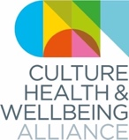
Sharing stories from creative professionals across the UK

“It’s time to bring the work of artists to the surface”
(Jenny Elliott, Arts Care CEO/Artistic Director, Northern Ireland)

Background
The Culture, Health and Wellbeing Alliance (CHWA), Arts Culture Health and Wellbeing Scotland (ACHWS), the Wales Arts, Health & Wellbeing Network (WAHWN) and Arts Care (Northern Ireland) have come together as a partnership of organisations and networks across the UK to find ways to support the culture, health and wellbeing sector during covid-19 and beyond.

Prior to this crisis, each organisation was already focusing on the need for greater support for freelance creative professionals (visual artists, musicians, theatre-makers, writers, designers, crafts people, etc) engaging with health and wellbeing. We recognise that across the four nations, support for freelance creative professionals remains an urgent priority – indeed that the precarity of the creative sector has been dramatically exacerbated at precisely the moment when its value for our physical and psychological wellbeing is becoming absolutely apparent.

Creative professionals have now begun to weave their way through this crisis, to adapt and respond in a multitude of ways that comprehend the complexity of covid-19 and all its ramifications, but remain true to the generous principles and professionalism within socially engaged practice.

We would like to ask five freelance creative professionals engaging with health and wellbeing from each nation to reflect on their responses. As organisations we will then bring these five responses together into a short report with our own reflections on key emerging themes across each nation.

We will reach these creative professionals by asking organisations in our networks to nominate someone they are already funding to undertake work. Although this initial snapshot of creative responses will be limited to a total of 20 (5 per UK nation), we would like to use this to open a wider call for reflections from creative professionals. We encourage anyone who would like to join this process to send their reflections via this google form.

We are particularly interested in reaching creative professionals who identify with one or more of the protected characteristics as defined in the Equalities Act 2010, as well as socioeconomic status.

Aims
Collectively these reports will be used to
- Share examples of innovative creative practice around the UK
- Reflect the value of this practice back to creative professionals across the UK
- Support professional development
- Bring together practice across the UK
- Underpin our conversations with policy-makers across culture, health and social care in all four nations, lobbying for support for creative and cultural professionals now and in the future

Timeline
Call out to partners/artists: Friday 1 May
Response by: Monday 18 May
Joint event during Creativity & Wellbeing Week discussing these examples
Reports from each nation: Complete by Monday 25 May

Please fill in the template and consent form overleaf and send both back to us by 9am on Monday 18 May.

For the nominating organisation
Please give us a short description of the project in which the creative professional you nominating is involved (up to 100 words), including a description of the primary participants or beneficiaries, funders and any weblinks.

NDCWales, Welsh Priority Venues/Dance Ambassadors.

Funders The Foyle Foundation
.
NDCWales supports 7 Welsh Priority Venues. Each Priority Venue has a ‘Dance Ambassador’ who is local to the venue, knows our repertoire and has received our training. Their role is to support the public to access the work of NDCWales and keep year-round contact with its communities Wales wide.

Delivery is informed by the dance already happening in local areas. This model supports local communities to become audiences and participants. This helps with engaging more people in a broader range of dance but also to sustain and develop the dance sector in Wales as more people engage with the artform.

Reflection from creative professional
(Please keep to between 100 and 300 words if possible)
This is an exceptional time for artists to explore and reflect on their work.
We invite you to share with us your experience and response if any, to the Covid-19 crisis as a creative professional. We are particularly interested in your individual stories, the impact of the crisis on your professional practice, how you have adapted and a project you may have been involved in within a health, social care and/or community context. In addition, you may want to include how you have supported your personal health and wellbeing through this crisis.

Before the COVID-19 crisis came, I was working as a Dance Artist in schools, a Dance Ambassador with NDCWales and with community groups. Some work has been postponed, though much has continued. The projects that have continued have shifted into a digital space and are being shared, as best as possible, with the spirit of the live interaction and emphasis of community that drives the work - including NDCWales’ Rygbi education pack and Ribidirês – early years dance sessions supported by Pontio. I am fortunate to have young children, who love to move and use their imaginations, and a supportive husband. This has allowed us to collaborate as a family to create learning resources that engage both children and adults in dance that supports children’s education and development.

Creating videos in this way has allowed me to use my work to support the wellbeing of my family, with the exploration and learning of my children becoming the heart of the work. We have made some wonderful memories as a family from within our home, whilst supporting the learning and development of our children. We have climbed through forests, flown to space and scored a try for Wales in a crowded stadium. Our hope is that through working as a family, we can give confidence to other families to use movement and dance to support their health and wellbeing at this difficult time. We hope to inspire families to get lost in a journey into the unknown from their own homes, to discover the power of touch and to learn through fun. Our hope is that through our work families can strengthen bonds and make magical memories, of meeting aliens and winning the Six Nations for Wales, and to allow themselves a minute to find the value in flying as freely as a butterfly, without a care in the world.

Biography (creative professional)
Please give us a short biography (up to 100 words) as well as a link to your personal site or a relevant project site if you have one.

Angharad is a Dance Artist working in North Wales. She has worked as a choreographer and dancer for companies such as Light, Ladd and Emberton, National Theatre Wales and Theatr Genedlaethol. She is co-director of Cymru:Brasil and intercultural performance company who create work inspired by Welsh and Brazilian culture. Angharad works across the community and within education delivering projects for companies including National Dance Company Wales (Dance Ambassador), Pontio and Theatr Clwyd. Angharad has a passion for Dance in Early Years and through her company Ribidirês runs bilingual classes to encourage a love of the Welsh language from an early age.

If you are submitting your reflections, we would be very appreciative if you could fill in CHWA’s online, anonymous, equality, diversity and representation form.

CONSENT FORM

Your consent
I hereby give my consent to the following organisations to use my words above, and any attached images/videos: the Culture, Health and Wellbeing Alliance (CHWA), Arts Culture Health and Wellbeing Scotland (ACHWS), the Wales Arts, Health & Wellbeing Network (WAHWN) and ArtsCare (Northern Ireland).

Each organisation undertakes to ensure that any images /videos are credited as follows:
Please give us the actual wording you would like to accompany your image or video including any credits needed to the person who took the image/made the film.
Image Credit Kirsten McTernan

I confirm that:
I hold the copyright for the images/photographs/videos above and/or that I have written permission to use them the copyright holders (please delete/cross out as appropriate): | Yes  No

I have written permission to use these images/photographs/videos from the people appearing in them | Yes  No

I consent for CHWA, WAHWN, ACHWS and ArtsCare using my text and the images /videos for:

Reports that will be shared with partner organisations and publicly | Yes  No
Websites | Yes  No
Newsletters | Yes  No
Press/PR – this includes sending images to media outlets including, print, TV and online | Yes  No
Social media | Yes  No

- If you change your mind about the use of your materials, please contact info@culturehealthandwellbeing.org.uk
- Please note that CHWA, WAHWN, ACHWS and ArtsCare cannot control other people’s use of the material once it has been published

Name Guy O’Donnell

Organisation (if applicable) National Dance Company Wales

Date 13/05/2020

Signature 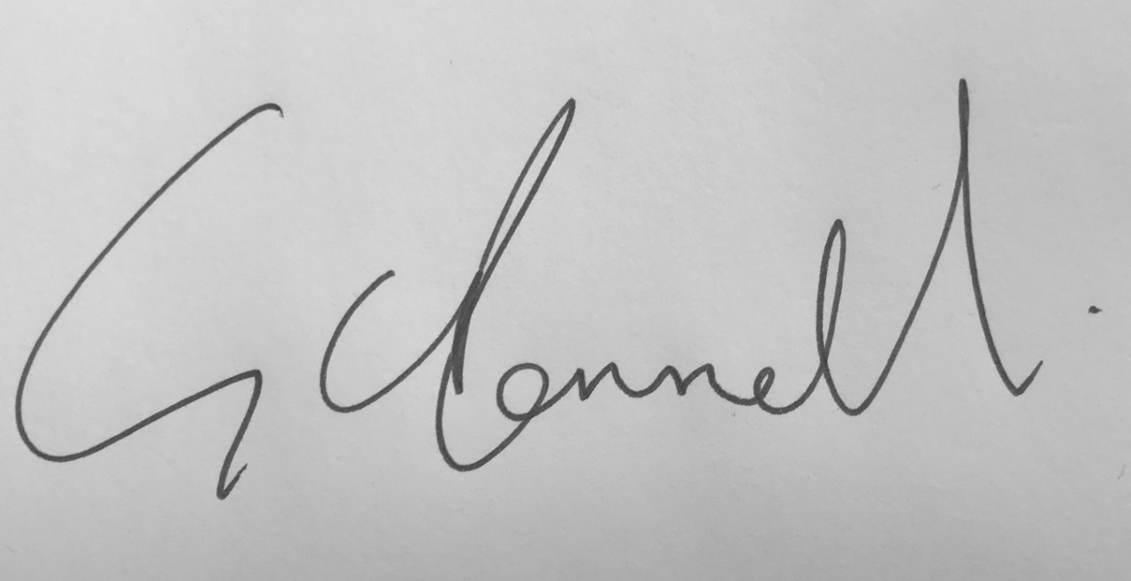_

Protected characteristics are age, disability, gender reassignment, marriage and civil partnership, pregnancy and maternity, race, religion or belief, sex, sexual orientation.

